KAILASH MANSAROVA YATRA
FIXED DEPARTURE – 2026: (Overland Trip) Ex Kathmandu – 14 Days
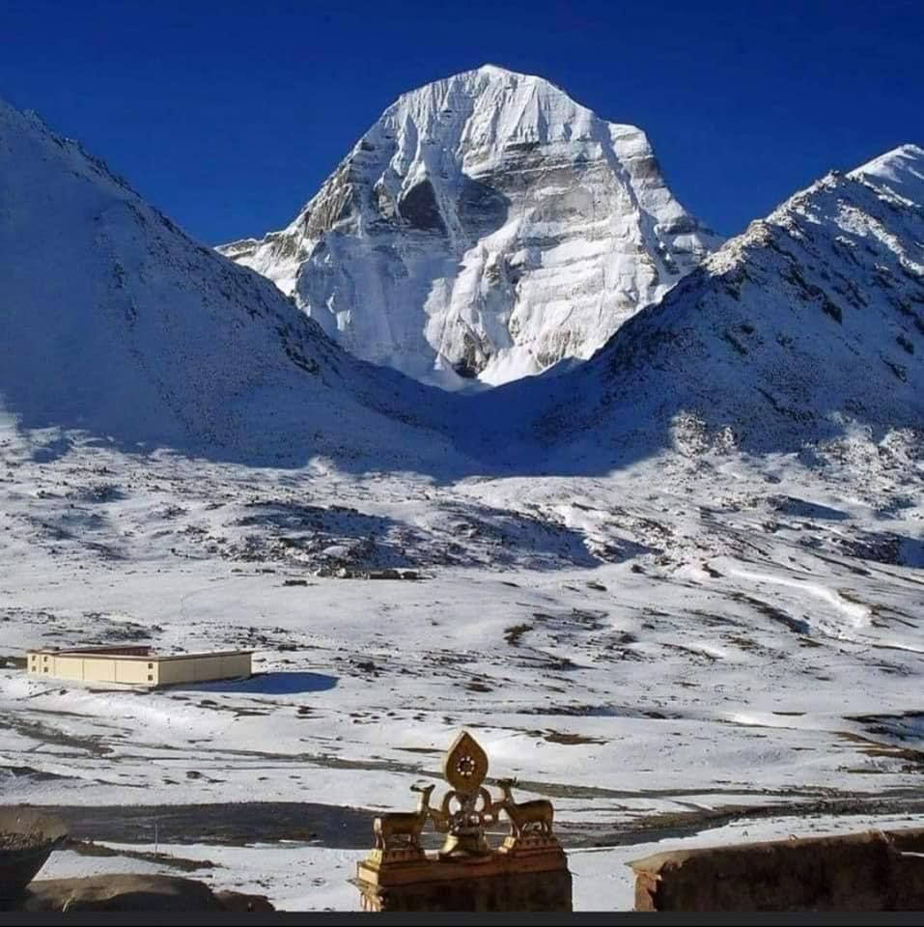

Embark on one of the most sacred pilgrimages in the world – the Kailash Mansarovar Yatra, a spiritual journey that combines breathtaking Himalayan beauty with profound cultural heritage. This divine expedition takes you through the serene landscapes of Nepal and Tibet, offering a rare chance to witness the majestic Mount Kailash (6,638 m), revered as the earthly abode of Lord Shiva, and the tranquil Lake Mansarovar, believed to cleanse the soul and wash away past sins.

The journey begins, where pilgrims acclimatize amid scenic valleys before crossing into Tibet via rugged high-altitude terrain. Each day unfolds with spectacular views of snow-clad peaks, vast plateaus, and ancient Buddhist monasteries. The highlight of the Yatra is the three-day Kora (parikrama) around Mount Kailash, a deeply spiritual walk that challenges the body but elevates the soul.

- Total Duration: 14 Days
- Max. Altitude: 5,700 meters (18,700 ft) at Dolma La Pass during the Parikrama.
- Pilgrimage Focus: Darshan of Mount Kailash, circumambula􀆟on (Parikrama/Kora) of Mount Kailash, and holy dip/puja at Lake Mansarovar.
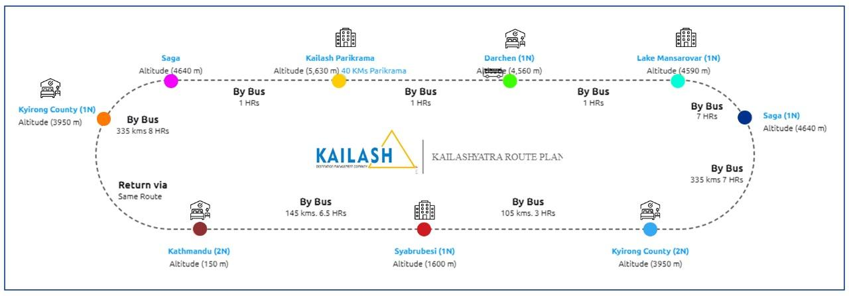

Sketch Itinerary & Altitude Profile:
Day | Route & Key Activities | Overnight at & Altitude | Driving/Flying/ Trekking Time
Day 1 | Arrive Kathmandu and transfer to hotel | Kathmandu / 3-star Hotel  1400 Mts./4600 ft | --
Day 2 | Kathmandu Cultural Tour | Kathmandu / 3-star Hotel  1400 Mts./4600 ft | --
Day 3 | Drive to Syabrubeshi or Timure | Syabrubeshi / Hotel / 1600 m | Dsitance:145 Kms / Drive: 6.5 hrs
Day 4 | Drive to Kerung Acclimatization Day in Taklakot. Free day for rest and exploring the local market. Critical for adjusting to high altitude. | Kerung / Hotel / 2,850 m | --
Day 5 | Drive to Saga | Saga / Hotel / 4550 mts. | Dsitance:220 Kms / Drive: 5-6 hrs
Day 6 | Saga Free day for rest and exploring the local market. Critical for adjusting to high altitude. | Saga / Hotel / 4550 mts. | Distance:220 Kms  Drive: 5-6 hrs
Day 7 | Drive to Lake Mansarovar (4550 m). En route see Rakshas Tal and first views of Mt. Kailash & Gurla Mandhata. Perform Mansarovar Parikrama by bus | Lake Mansarovar / Basic Mud House  4,550 m / 14,925 ft | Drive: 1.5 hrs (90 km)  Parikrama by Bus: 3 hrs (105 km)  --
Day 8 | Drive to Darchen Take holy bath in Mansarovar Lake and conduct Pooja | Darchen / Hotel 3 | Distance: 35 Kms / Drive: 01 hrs
Day 9 | Drive to Yam Dwar. Start Kora (Parikrama) - Day 1. Trek to Diraphuk. View the West Face of Kailash. | Diraphuk / Basic Mud House  4,880 m / 16,010 ft | Drive: 1.5 hrs (43 km) / Trek: 5-6 hrs / Distance: 12 km
Day 10 | Kora - Day 2 (Most Challenging). Trek to Dolma La Pass (5700 m) and then descend to Zuthulphuk. | Zuthulphuk / Basic Mud House  4,670 m / 15,322 ft | Trek: 8-9 hrs / Distance: 22 km
Day 11 | Kora - Day 3 (Final). Short trek to Maniwall. Drive to Darchen and then back to Saga. Rejoin group. | Taklakot / 3-star Hotel / 3,900 m | Drive: 3-4 hrs / Trek: 3 hrs / Duration: 07-08 hrs  Distance: 470 km
Day 12 | Drive to Kerung | Kerung / Hotel / 2850 mts. | Distance:220 Kms  Drive: 5-6 hrs
Day 13 | Drive to Kathmandu | Kathmandu / 3-star Hotel  1400 Mts./4600 ft | Distance:192 Kms / Drive: 8-9 hrs
Day 14 | Drive to Airport. Tour concludes. Depart for home destination.

Kathmandu Arrival Date (2026)

*Bookings must be finalized at least 45 days before the intended travel date.

Month-2026 | Date
May | 07, 14, 21, 25 (Full moon), 28
Jun | 04, 11, 18, 24 (Full Moon)
July | 02, 09, 16, 23 (Full Moon), 30
August | 06, 13, 20, 22 (Full Moon), 27
September | 03, 10, 17, 20 (Full moon)

Itinerary (Kailash Mansarovar Yatra ex Kathmandu Overland Trip – 14 Days)

Day 01: Arrival Kathmandu (1400 Mts. / 4600 ft)

On Arrival at Kathmandu Airport, you will be greeted by our office representatives / driver outside of arrival gate. Then continue driving to hotel & meet other members joining your group.
Meal - Lunch if you arrive early & Dinner

Day 02: Kathmandu cultural Tour

After breakfast drive to Pashupatinath temple (Darshan, Perform Puja) & Visit Buddanilaknatha then drive back to hotel. Packing and preparation for yatra evening short briefing about further program.
Meal - Breakfast, Lunch & Dinner at hotel.

Day 03: Drive to Syabrubeshi (1600 mts. /145kms) or Timure (1983Mts. /152 kms.)

This is the first day of the Yatra, Morning after breakfast depart from Kathmandu to Syabrubeshi (1600m / 145 km / 6.5 hrs.) near China border by reserved tourist coach.
Meal - Breakfast in Kathmandu, Lunch on the way in good restaurant & Dinner in Syabrubeshi

Day 04: Drive to Kerung (2850mts.)

Drive to Rasuwagadhi (1800m / 15 km / 45 min from Syabrubeshi), then our Guide will complete custom formalities and continue further drive to Kyirong (2850m) – 1 hrs. / 35 km
Meal: Breakfast in Syabrubeshi, Lunch & Dinner in Kerung

Day 05: Drive to Saga (4550mts)

After Breakfast drive to Saga / (220 km – 5 to 6 hrs.) enroute passing Thorong La, Paigu-Tso Lake and Brahmaputra River.
Meal - Breakfast in Kerung, Packed Lunch enroute & Dinner in Saga

Day 06: Saga (4550mts)

Entire day free for acclimatization.
Meal - Breakfast, Lunch & Dinner

Day 07: Drive to Mansarovar (4550mts. / 450 kms)

After breakfast drive from Saga to Mansarovar Lake (7hrs) crossing beautiful places & Conducting Mansarovar Lale Parikrama by Coach (105 km. 03 hrs. Drive)
Meal: Breakfast in Saga, Packed Lunch enroute & Dinner in Mansarovar

Day 08: Drive to Darchen (4600mts. - 35kms)

Morning Take holy Bath in Manasarovar Lake and conduct Pooja, hawan and spiritual activities according to your tradition then drive towards Darchen (1 hrs. drive)
Meal - Breakfast in Mansarovar, Lunch & Dinner in Darchen

Day 09: (Starting of 1st Day Kailash Parikrama) Trek to Diraphuk (4880 mts. - 12kms; 05 to 06 hrs. trek)

After breakfast we will drive to Yamadwar (43Km - 1.5hrs drive). From Yamadwar you can view south face of Kailash Parbat. This is the starting point of Parikrama. Trek 05 - 06 hrs., 12km. On the way to Diraphuk you can view west face of Kailash Parbat on the right side.
Yatries who do not want to go parikrama can come back to Darchen and wait for other members to arrive.
Yatries who cannot walk can hire horses for parikrama in Yamadwar at your own cost.
Meal - Breakfast in Mansarovar, Packed Lunch during trek & Dinner in Diraphuk

Day 10: (2nd Day of Parikrama) Trek to Zuthulphuk (4670m. 22km - 08 to 09 hrs. trek)

After breakfast trek from Diraphuk to Dolma La pass (5700m.). This is the most difficult journey throughout the yatra since you must trek up to 18,600 ft. About 3km before reaching Dolma La Pass is steep hill and quite difficult to walk. Also descending from Dolma La Pass is the same for up to 3km (You can see Gauri Kund on the right) then continue trek to Zuthulphuk.
Meal - Breakfast in Diraphuk, Packed Lunch during trek & Dinner in Zuthulphuk

Day 11: (Ending Day of Parikrama, 8 Km - 3 hrs. trek) Trek to Darchen & Drive to Saga (470Kms. / 07 to 08 hrs. drive)

After breakfast short trek to Maniwall (8 km - 3hrs trek). Our Coach will pick you from there then we will drive to Darchen (3 km.) and merge with other members who are waiting for us to complete parikrama and continue drive back to Saga (7-8 hrs. drive)
Meal - Breakfast in Zuthulphuk, Packed Lunch enroute & Dinner in Saga

Day 12: Drive to Kerung

Drive back to Kerung (220kms. 05-06 hrs. drive), which is the last stay in Tibet part.
Meal - Breakfast in Saga & Packed Lunch enroute & Dinner in Kerung

Day 13: Drive back to Kathmandu

Drive from Kerung to the border (40kms - 1hrs) and completing immigration formalities drive back to Kathmandu - around 7- 8 hr. / 152 km. Arrive at Kathmandu hotel.
Meal - Breakfast in Kerung, Lunch enroute in good restaurant & Dinner in Kathmandu

Day 14: Departure

After breakfast drive to Kathmandu International Airport to move towards your own destinations
Meal - Breakfast

Currency in Tibet: The Chinese Yuan (CNY). Can be exchanged from a bank or local money changers.

Package Includes:

- All transfers as per program.
- Nepal Side accommodation as per itinerary on double/triple sharing basis & Rest on 04 to 06 sharing basis.
- Arrival departure and sightseeing as per itinerary.
- Kathmandu/Kerung/Kathmandu by Tourist Bus
- Pure Vegetarian Meals (Breakfast, Lunch and Dinner) prepared by our escort in Tibet side
- Luxury coach transport in Tibet.
- Nepali Team leader and supporting team
- English speaking Tibetan guide
- Chinese visa
- Permit fee.
- Duffel Bag, Day Pack (Small Shoulder Bag) and Jacket.
- Oxygen cylinder and First aid Kit (Medical Purpose Carried by Our Sherpa Team)

Package Excludes:

- GST Extra.
- Home-Kathmandu-Home Airfare.
- Cost for extra night accommodation.
- Horse Ride or Porter during Parikrama.
- Evacuation cost.
- Travel insurance & Expenses of personal nature etc.
- Visa splitting Charge & Extra transport cost, if returning early from Tibet.
- Tips for Nepali Sherpa/Chinese Team @ CNY 200
- Any service not mentioned.

Booking Requirements & Procedure:
- Passport Validity: Must be valid for at least 6 months from the date of travel.
- Passport Pages: Must have a minimum of 2 blank pages.
- Existing Visa: Any existing valid Chinese visa in the passport must be cancelled before travel.
- Process:
o Submit an advance booking amount along with a Xerox copy of your passport.
o Submit your original passport to the Delhi office 10-15 days before travel for visa processing.

Cancellation Policy

- After Booking: INR 25,000 is non-refundable.
- 20 days before departure: 50% of the total trip cost.
- 15 days before departure: 90% of the total trip cost.
- 10 days or less before departure: 100% of the total trip cost.
- All cancellations must be sent in writing; verbal cancellations are not accepted.

Critical Risk Acknowledgement (As per Operator)

- Before booking, Yatries must understand and accept the following:
- The operator is not responsible for accidents or delays in evacuation due to natural calamities in the remote terrain.
- The operator is not liable for any illness due to the hazards of high-altitude travel where emergency treatment is unavailable.
- No refunds will be issued for changes or cancellations imposed by Chinese authorities or other factors beyond the operator's
- control.
- This is a physically demanding and high-risk journey. Yatries undertake this travel entirely at their own risk.

Note – The Tour Operator or any of its partners shall not he held responsible/liable for any change/delay in the schedule due to weather
Any extra cost incurred has to be paid by the clients.

Essential Packing List & Guidelines

- Clothing (No Sarees): Indian women pilgrims are strictly advised not to wear sarees.
- Must-Haves: Good quality hiking shoes, woollen thermals, warm trousers, woollen, shirts, sweater/jacket, raincoat, woollen cap,
gloves, woollen socks.
- Gear: Walking/hiking sticks, torch/flashlight, water bottles, toilet paper, sunglasses, sunscreen (high SPF), towel.
- Medicines: Personal prescriptions and Diamox (for altitude sickness-consult a doctor for dosage).
- Snacks: Energy-giving food like chocolates, dry fruits, toffees, and glucose.

Health Advisory & Altitude Warning

- Fitness Level: This is one of the toughest high-altitude journeys. You must be in excellent physical health.
- Medical Check-Up: A thorough check-up by your doctor is mandatory, especially for those with pre-existing heart or respiratory conditions like asthma.
- Altitude Sickness: Symptoms like headache, nausea, loss of appetite, and breathlessness are common. The acclimatization
day in Taklakot is crucial.
- Precautions: Drink 3-4 litters of water daily, avoid alcohol and smoking, do not over-exert, and inform your guide immediately
of any severe symptoms.

Risks & Liability

Travel Company and its associates will put every effort into making your journey smooth and pleasant. However, all the tours in Tibet are conducted strictly under the rules & regulation of Tibet Tourism Bureau (TTB). Therefore, Travel Company and its counterpart shall not be responsible for any change and alteration in the program due to unavoidable circumstances such as landslide, road blockage, flood, snow, political unrest, cancellation of flight, delay arrival, delay issue of permit and visa, sickness or accidents. Any extra cost incurred thereof shall be borne by the clients on the spot.
Please Note: Package price may increase if any changes occur in fuel prices / others due to the prevailing war situation. Any such increase in operational costs will be borne by the traveler.

